|  |  |  |
| --- | --- | --- |
| **MODULE:** 13 | **LESSON:** 4 | AREA OF POLYGONS |

Sometimes you can use area formulas you know to help you find the area of more complex figures.

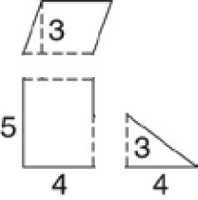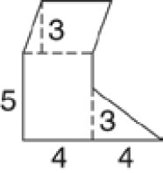You can break a polygon into shapes that   
you know. Then use those shapes to find   
the area.

The figure at right is made up of a   
triangle, a parallelogram, and a rectangle.

|  |  |  |
| --- | --- | --- |
| **Triangle** | **Parallelogram** | **Rectangle** |

Finally, find the sum of all three areas.

6  12  20  38

The area of the whole figure is 38 square units.